**Week 4 Module 4.2 Assignment**

Juan Macias Vasquez

Bellevue University

CSD310-H323 Database Development and Use (2255-DD)

**Adam Bailey**

June 20th, 2025

Module 4.2 Assignment My SQL

Assignment: My SQL and movies

My SQL

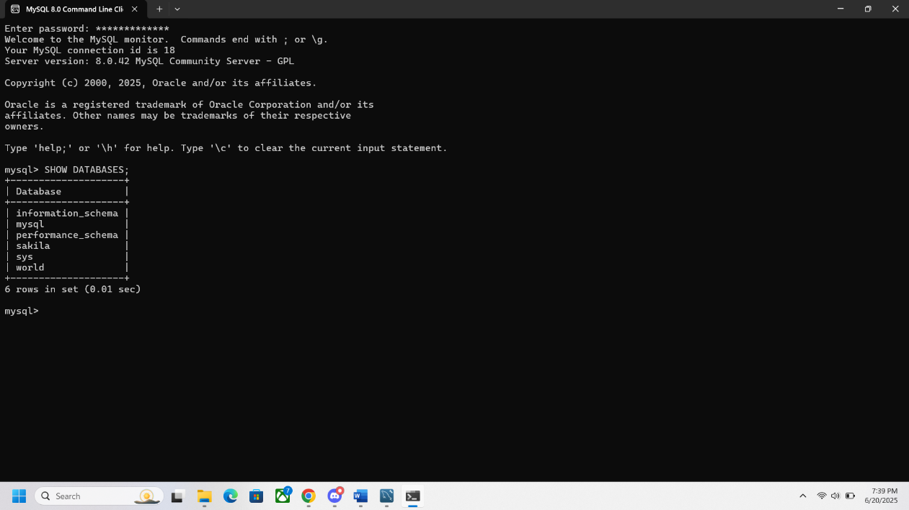

After adding Movies Database

